|  |  |
| --- | --- |
|  | KJSCE/IT/TY BTECH/SEM VI/DL (H)/2023-24 |
| **Batch: HONS-4** | **Roll Number: 16010421119 Experiment Number: 01** |
|  |  |

**Title of the Experiment: Back propagation algorithm (VLAB)**



**Output:**

**CLASSIFICATION-**

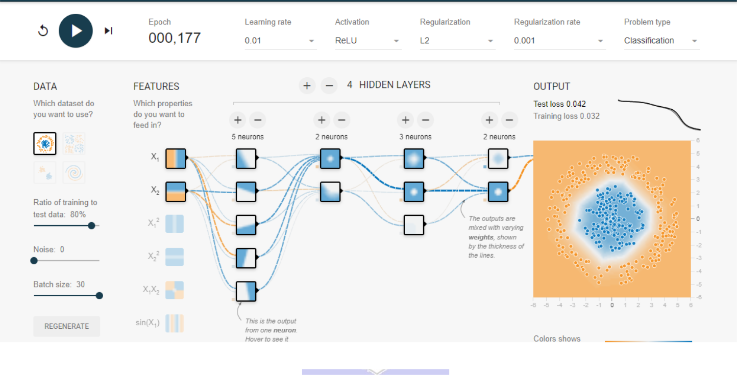

(A Constituent College of Somaiya Vidyavihar University)

KJSCE/IT/TY BTECH/SEM VI/DL (H)/2023-24

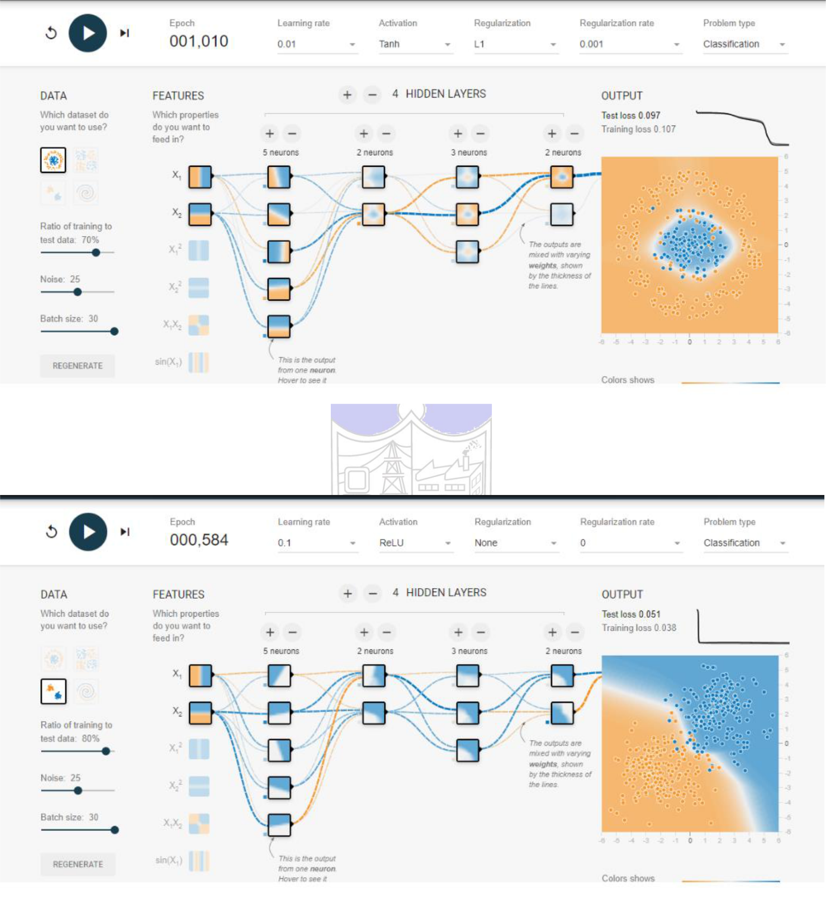

(A Constituent College of Somaiya Vidyavihar University)

KJSCE/IT/TY BTECH/SEM VI/DL (H)/2023-24

**REGRESSION:**

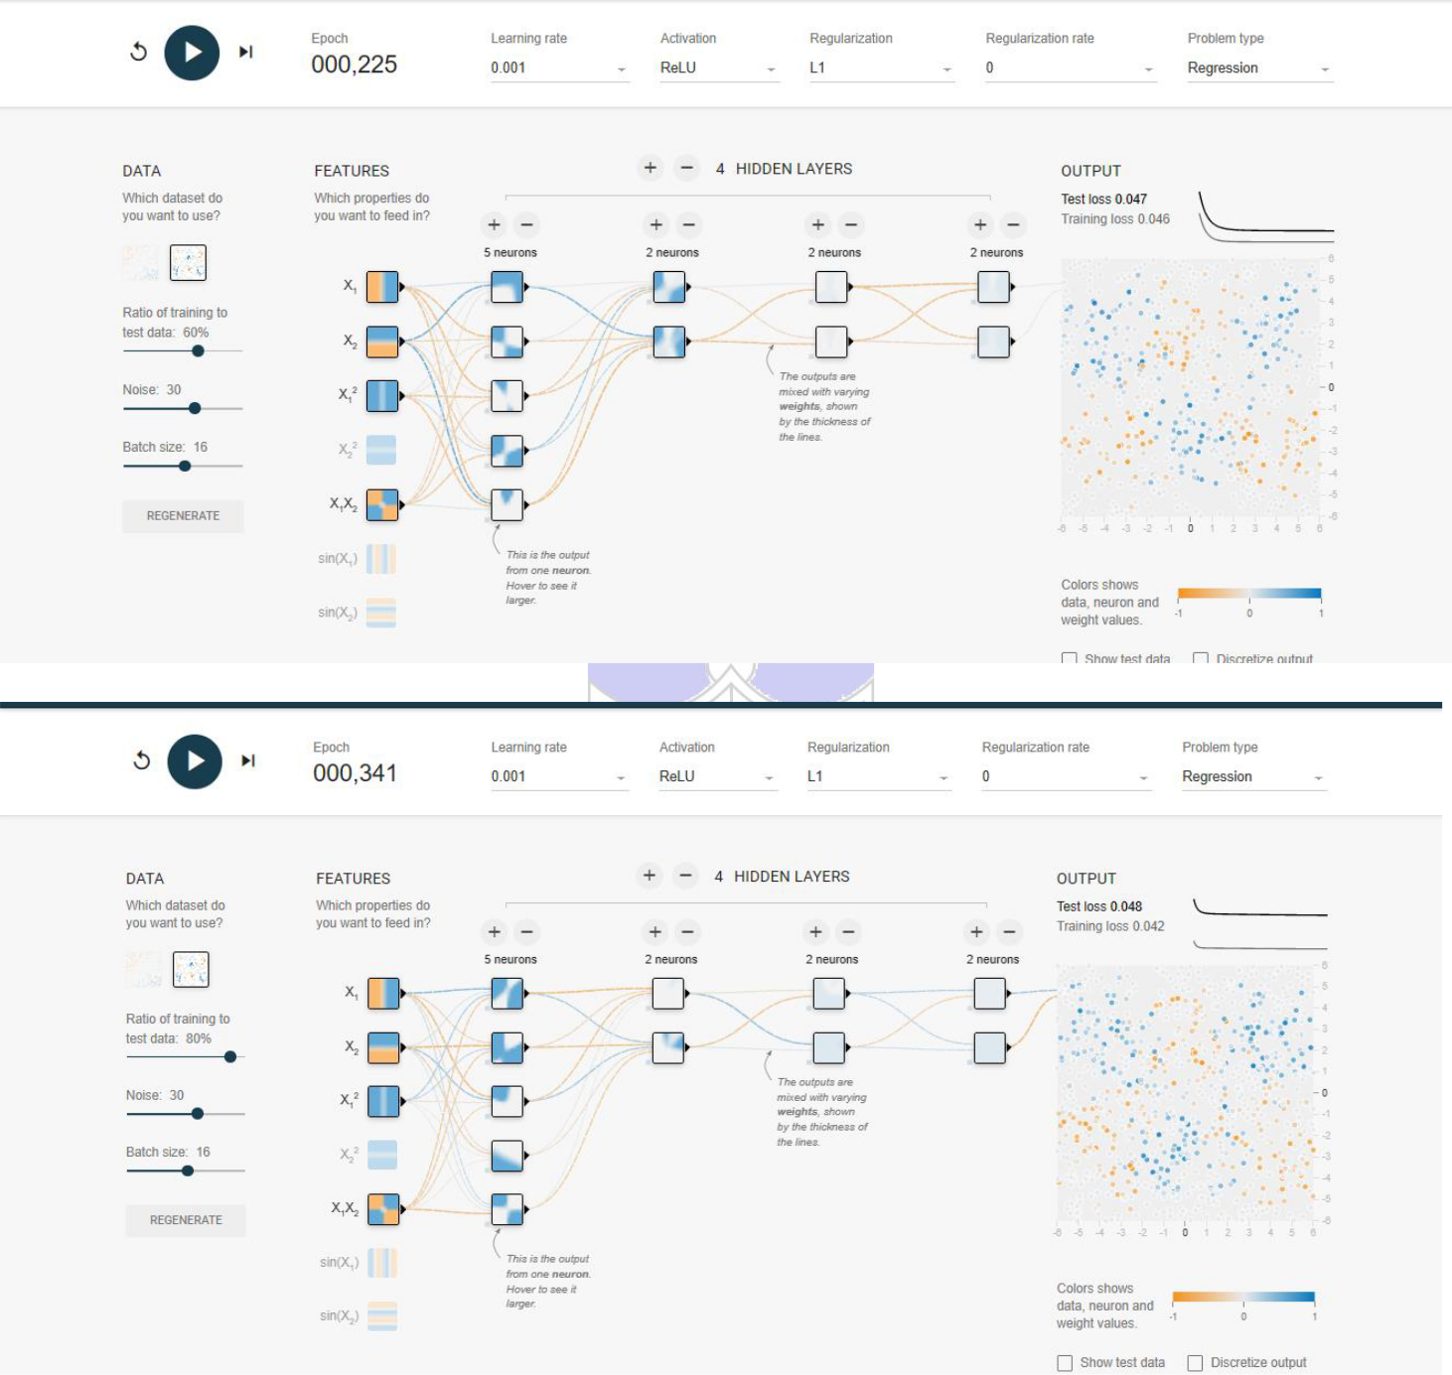

(A Constituent College of Somaiya Vidyavihar University)

KJSCE/IT/TY BTECH/SEM VI/DL (H)/2023-24

**Post Lab Question- Answers (If Any):**

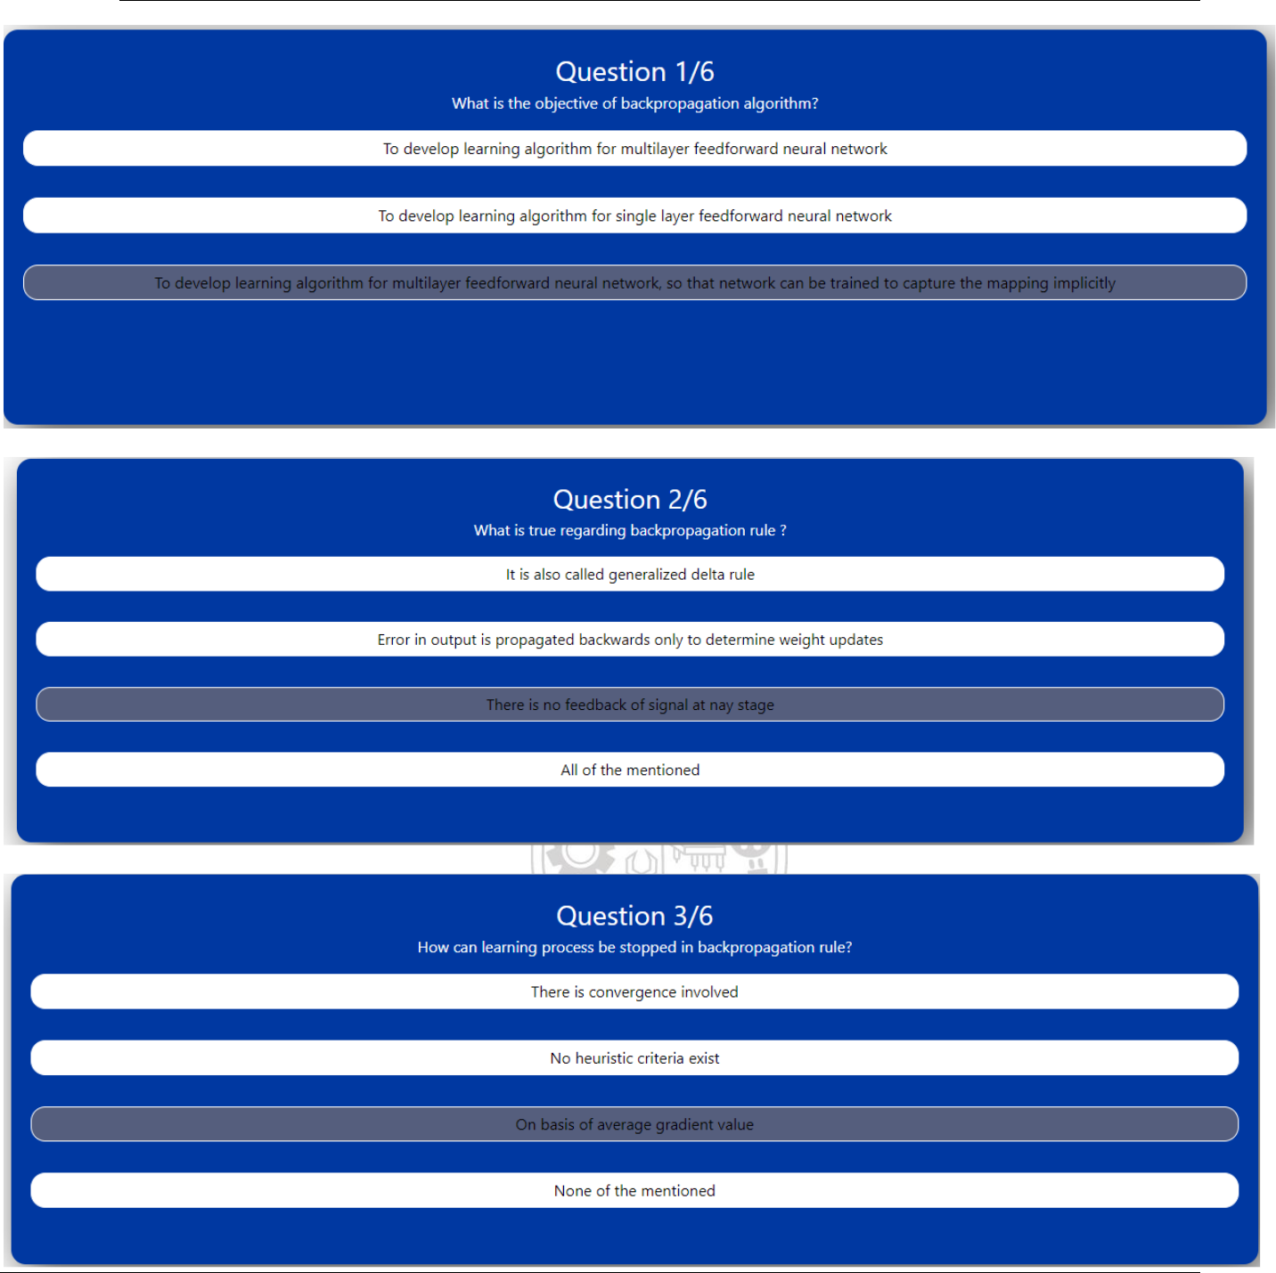

(A Constituent College of Somaiya Vidyavihar University)

KJSCE/IT/TY BTECH/SEM VI/DL (H)/2023-24

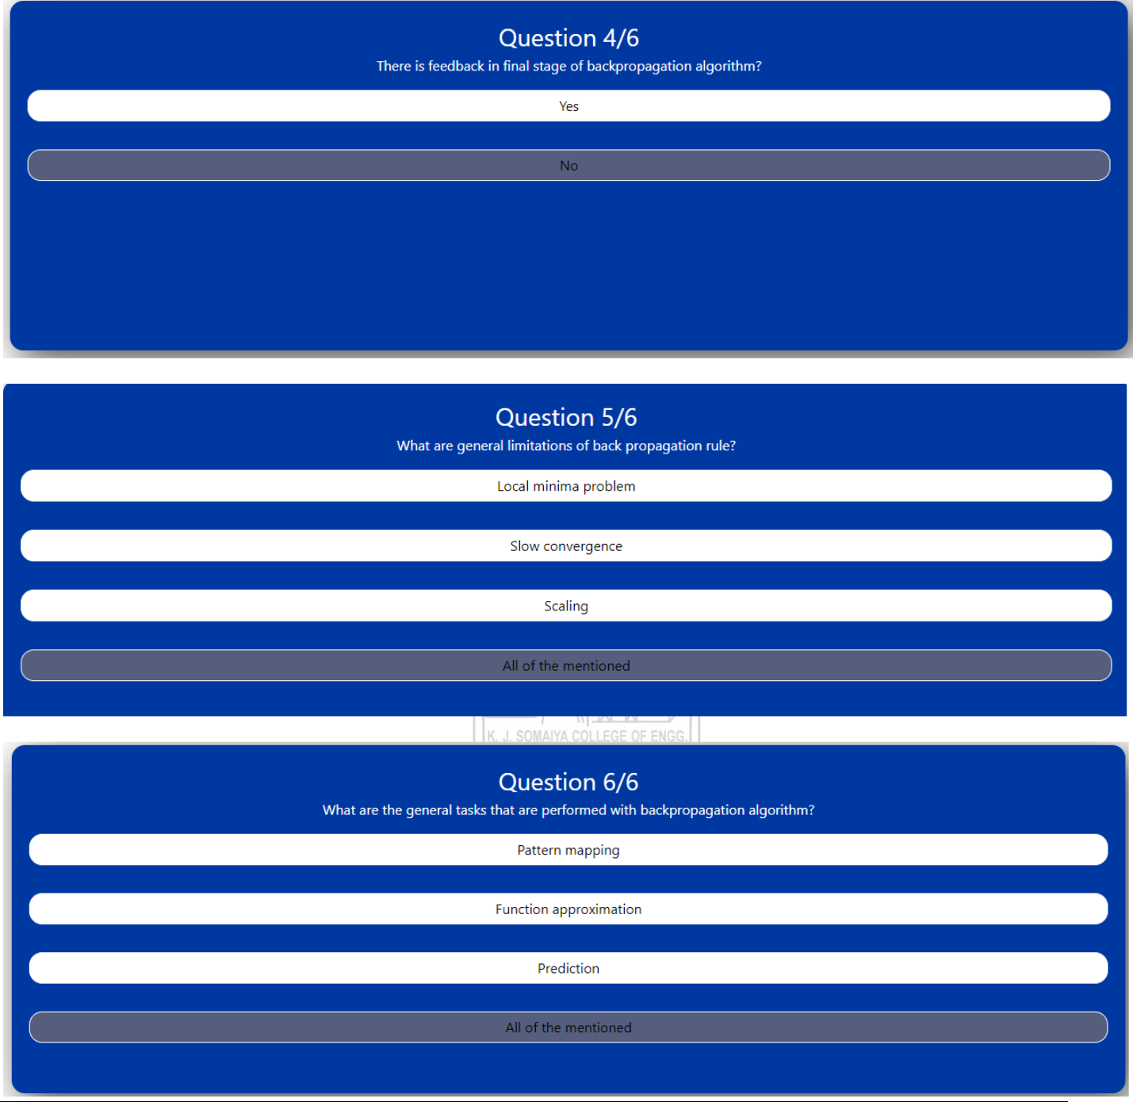

(A Constituent College of Somaiya Vidyavihar University)

KJSCE/IT/TY BTECH/SEM VI/DL (H)/2023-24



**CO:**

**CO1: Understand the evolution of deep learning.**



**Conclusion:**



**In this experiment, we learnt how to simulate a neural network, to minimize the test loss, training loss and error and optimize weights.**

(A Constituent College of Somaiya Vidyavihar University)